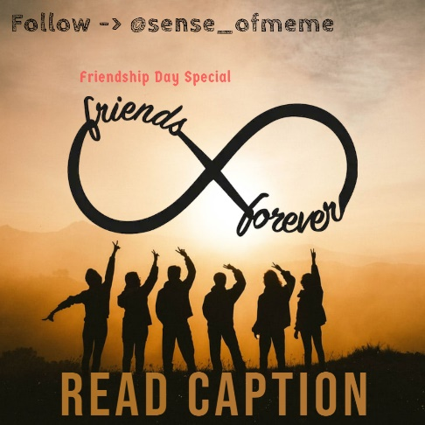

This is for my squad, my friends, the comedy king of our gang, the anytime ready to fight guy, the foodie peeps, the person with a beautiful smile, the one who taught us all just before the exams, I miss you guys.  
  
I know you all are scared and a bit nervous that how this all will be gone and over. We’re about to graduate in a few years and as scary as it is, I want you to know that it’s going to be okay. I know the only trips we made together were in our college only  but I promise you guys, someday, I’ll hit you up with plane tickets and we’ll have our ‘Dil Chahta Hai’ trip.  
  
I always thought college was supposed to make you ready for the life ahead, but it was you guys who made it bearable. You guys made me realize that it’s very easy to breathe, to stop and live in the moment, to feel like a child, and behave like one, too.  
  
As stubborn as each one of you is, you made your way into my heart and made sure my gallery was flooded with all of your faces. Today, I have more photos of you guys than anyone else. Those pictures have memories and sounds that I wish I could tell you how beautiful we sound laughing. I miss laughing and I hope when we meet next, we’ll all have new jokes to tell and new memories to make.  
  
If I knew how long we would be away from each other, I would have hugged you all a little tighter, drank an extra cup of chai together, and probably would’ve stayed back in the college canteen for a few more hours. Imagine me rolling my eyes and saying I love you to each one of you because if I could, I would do that right now.  
  
Because of you only, I met some idiots who are like my lifelines, despite being in another city ❤️ .  
  
------------------------------------------------------------  
  
✍️ Written By : [@sense_ofmeme](https://www.instagram.com/sense_ofmeme/)  
  
------------------------------------------------------------